MY Cyber 2024 Compliance for Log360
Strengthen data protection and meet MY Cyber 2024 compliance with Log360.
Region: Malaysia | Type: Data Privacy, Incident Management | Category: Compliance | Pricing: Free

Overview
The MY Cyber 2024 compliance extension in Log360 helps organizations meet the Malaysia Cyber Security Act 2024 (Act 854), Malaysia's national cybersecurity law establishing the National Cyber Security Committee and defining NCII across 11 critical sectors with mandatory risk assessments and incident reporting by providing centralized log management, real-time threat detection, and compliance audit capabilities. The platform supports MY Cyber 2024 requirements for governance, NCII protection, incident reporting, access control, security audits, network security, data protection, and third-party risk.
For Governance and National Oversight, Log360 tracks AD policy changes, GPO configurations, user and group auditing, and OU management to evidence compliance. To address NCII Protection and Asset Management, the platform monitors Windows program inventory, software updates, registry changes, and vulnerability scanner integration. The extension also supports Incident Reporting and Response by providing capabilities that provides threat detection from FireEye, Trend Micro, McAfee, network attack logs, and backup malware reports.

Key Features
- Access Control and Authentication: Log360 captures Windows and Unix logon/failed logon events, AD and Entra ID MFA logon, and MFA authentication records.
- Cybersecurity Audits and Risk Assessment: Log360 aggregates Windows system events, EventLog data, database audit logs, and vulnerability scanner outputs for audit support.
- Network Security and Perimeter Defense: Log360 audits network device logon, account management, policy changes, attack reports, and firewall security configurations.
- Data Protection and Business Continuity: Log360 tracks file changes, registry modifications, backup infrastructure status, job statuses, and Windows Backup events.
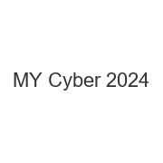
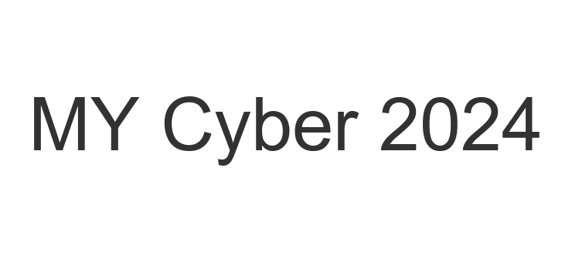
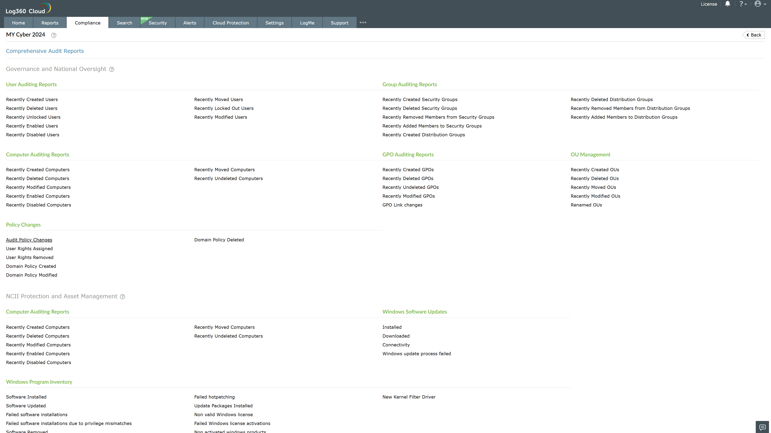
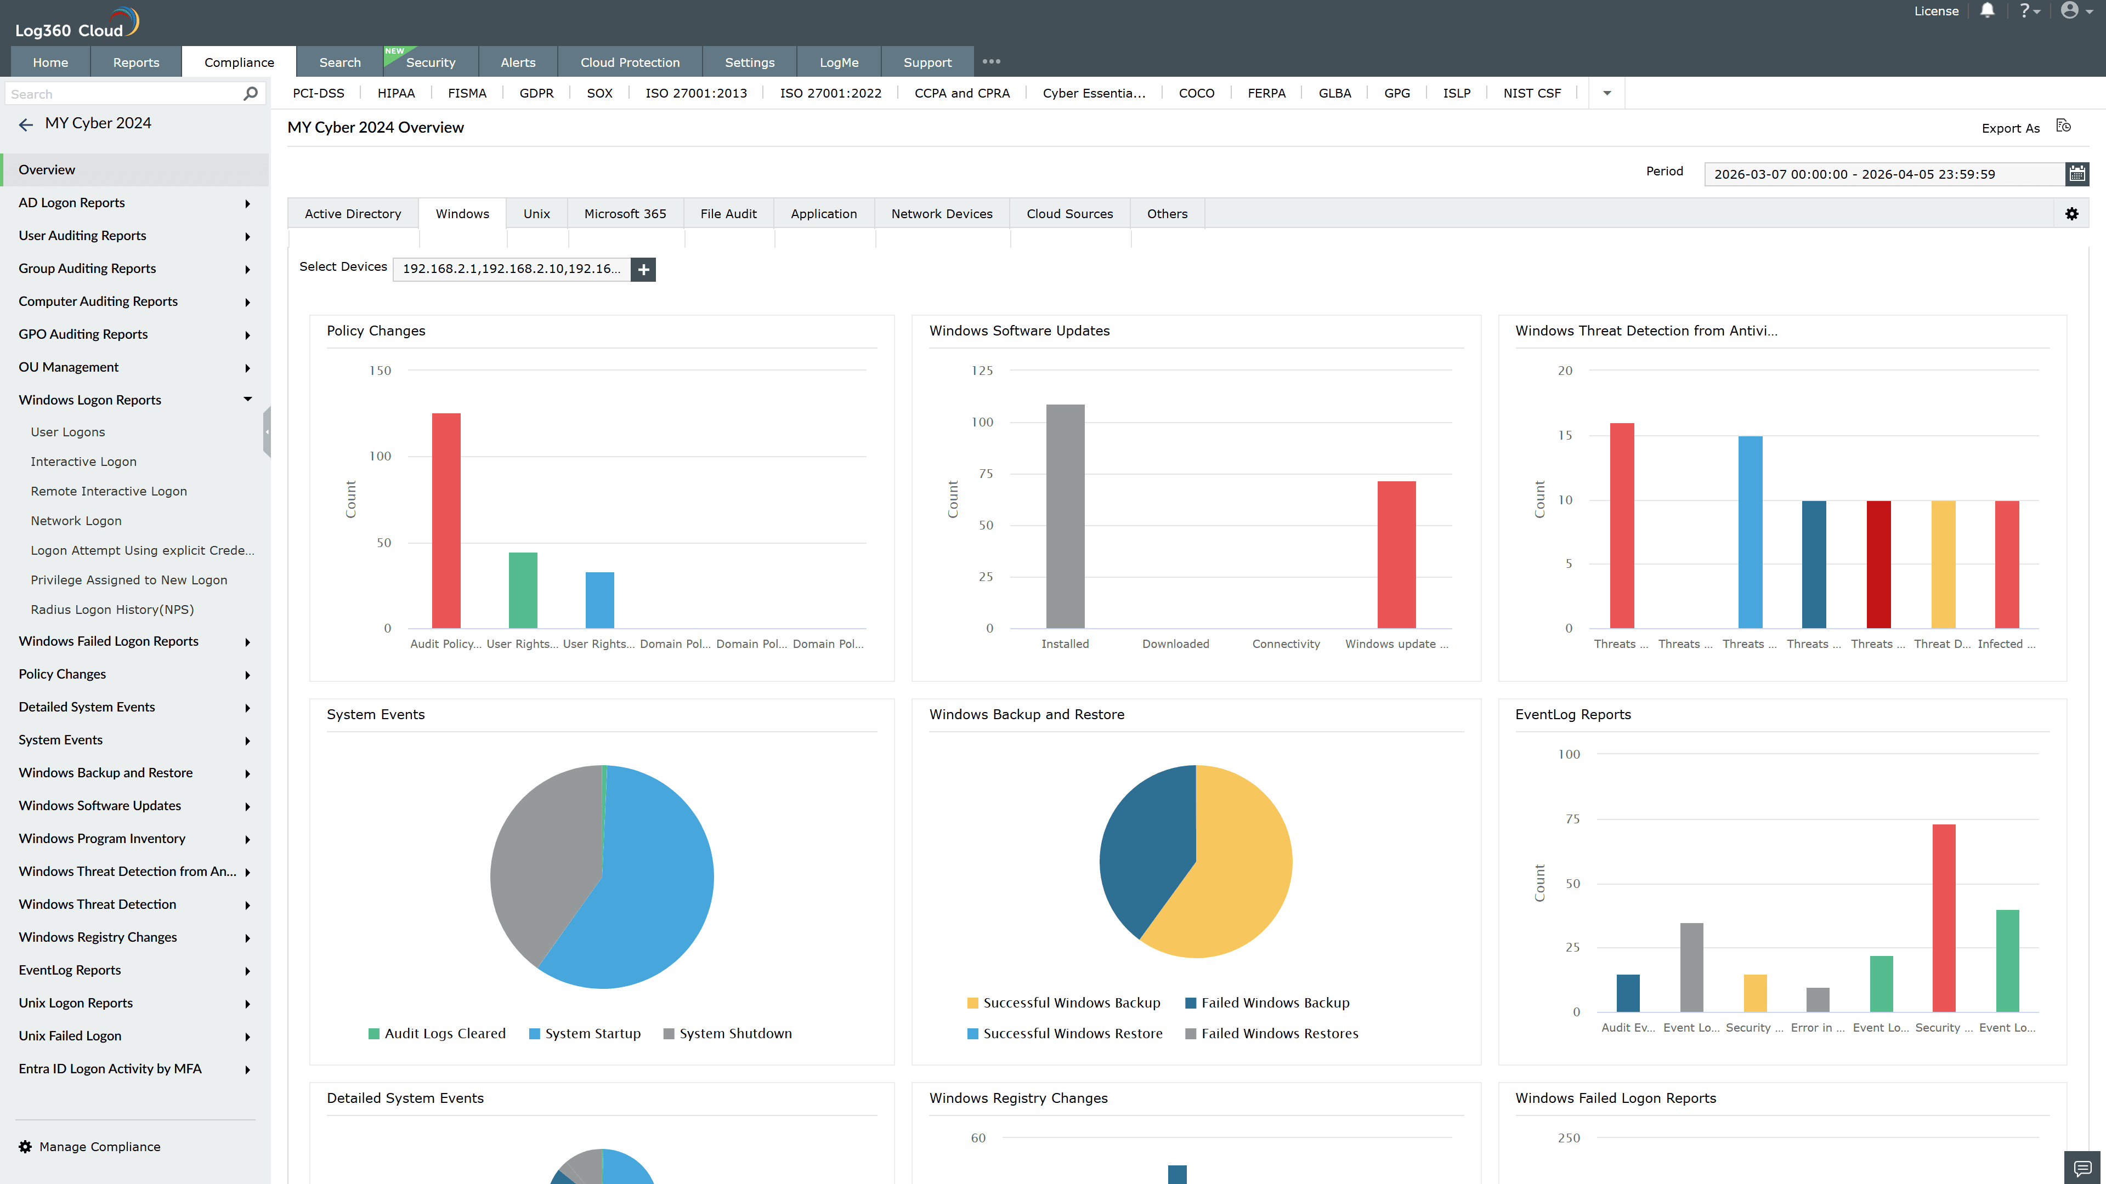
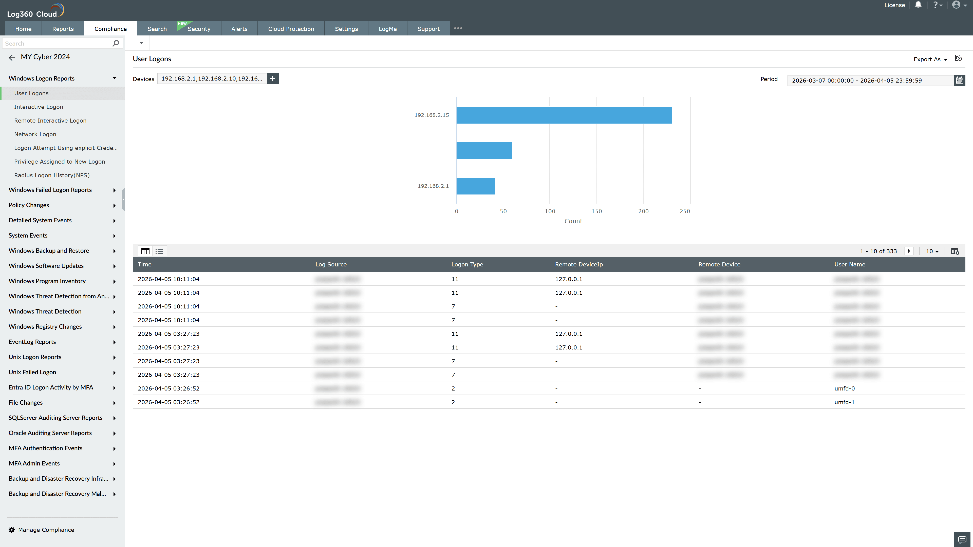
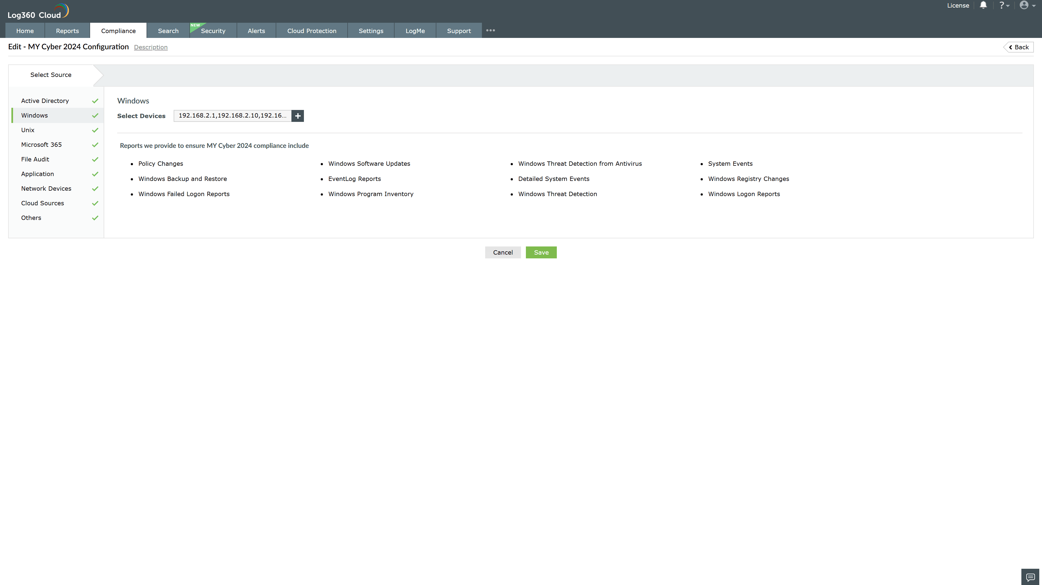
Valid Submission : Yes
Supported Editions : Free, Basic, Standard, Professional, MSSP
Help Document : https://www.manageengine.com/log-management/help/integrations/compliance-extensions.html
Help Video : Not provided
Tags : Log360, Compliance, Privacy monitoring, Data privacy, Regulatory compliance
Supported DCs : US, IN, JP, CA, AU, UK and EU
Privacy Policy:
Terms of Service:
Release Notes:
Predefined reports for the MY Cyber 2024.

